**Agents in Azure DevOps Pipeline**

* Azure DevOps Pipelines have two types of Agents
  + Microsoft hosted Agents
    - <https://learn.microsoft.com/en-us/azure/devops/pipelines/agents/hosted?view=azure-devops&tabs=yaml> for the official docs
    - Size is always fixed Standard_D2S i.e. 2 vcpu's 8 GB RAM
    - When to use:
      * Build/Deploy uses standard tools/softwares and if the configuration required matches the above statement
      * No/Little configuration is what you like in CI/CD pipelines for executions
  + Self-Hosted Agents
    - <https://learn.microsoft.com/en-us/azure/devops/pipelines/agents/linux-agent?view=azure-devops> for docs
    - You need to configure agent to connect to azure devops
* Azure DevOps Pipleines can be summarized as shown below  
  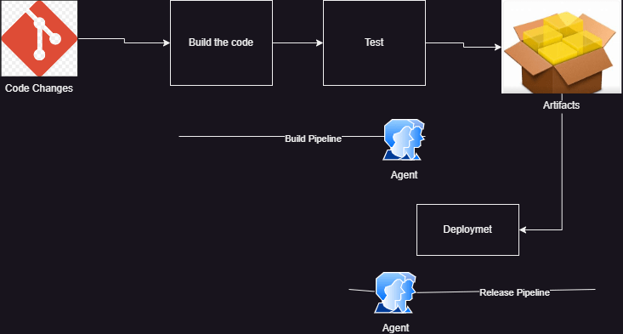
* Build pipeline: When maven is involved.
* Release pipeline: Where artifact is involved

**Exercise: Setting up agent to build jdk 17 and maven based softwares**

* Create a linux vm
* install jdk 17 and maven

sudo apt update

sudo apt install openjdk-17-jdk maven -y

Now navigate to project settings and agent pools  
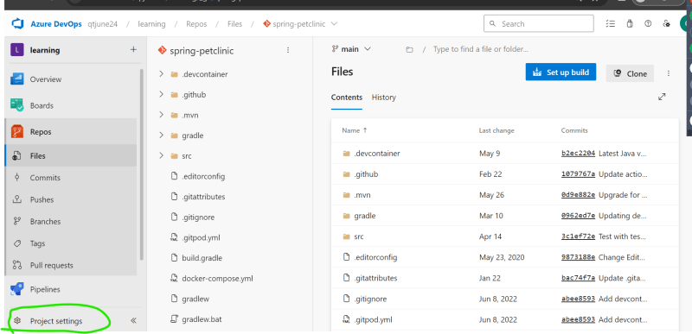  
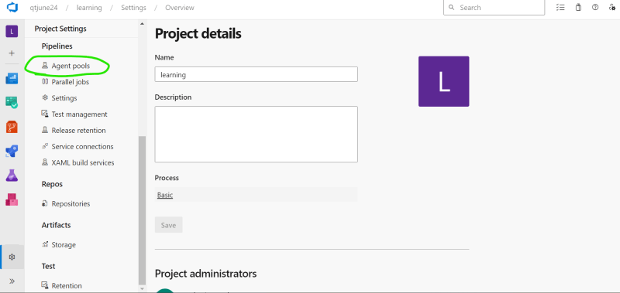  
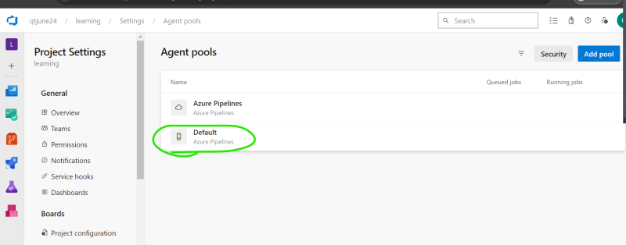  
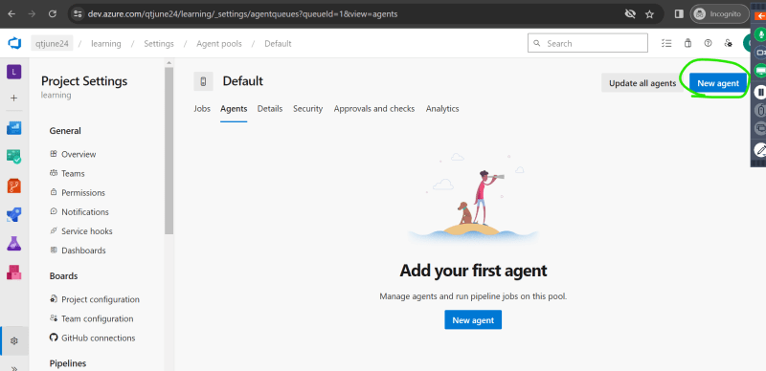

* Now configure account and permissions <https://learn.microsoft.com/en-us/azure/devops/pipelines/agents/windows-agent?view=azure-devops#permissions>

Configure the agent according to the steps on documentation  
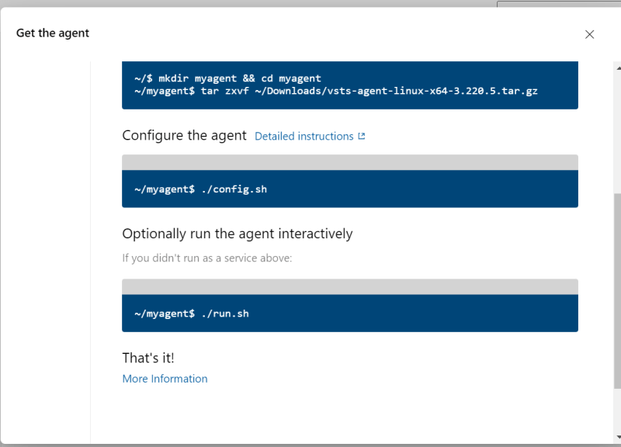  
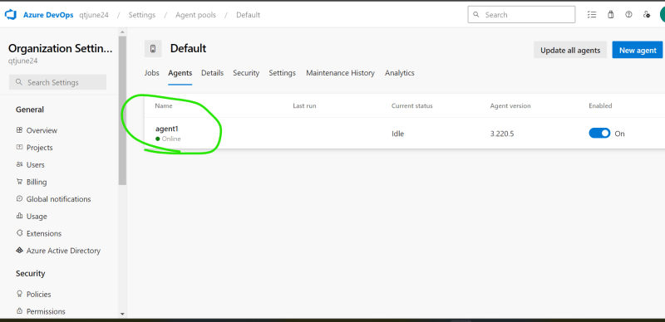

Now lets try to create a simple azure devops build pipeline

# Starter pipeline

# Start with a minimal pipeline that you can customize to build and deploy your code.

# Add steps that build, run tests, deploy, and more:

# https://aka.ms/yaml

trigger:

- main

pool:

name: Default

steps:

- bash: printenv

Run the pipeline  
